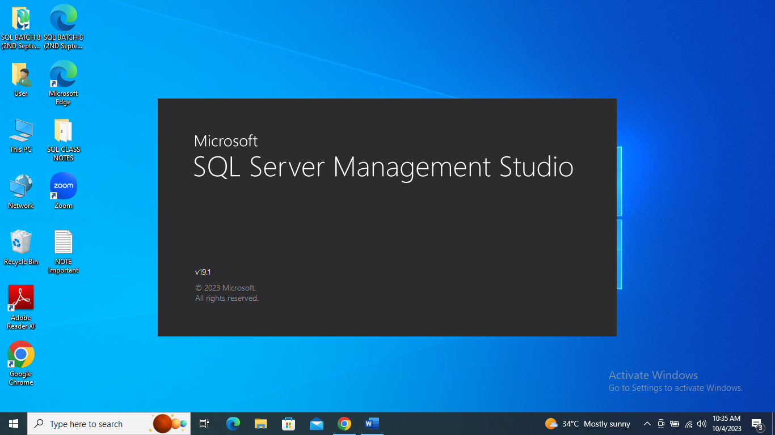

**2.Give the difference between Char and Varchar data type.**

**1. CHAR (Character):**

- CHAR is a fixed-length character data type.

- When we define a CHAR column, we must specify a fixed length, such as CHAR(10).

- CHAR is fixed-length and always reserves the specified space

- Use CHAR when we have fixed-length data or need consistent column sizes.

**The main difference between CHAR and VARCHAR depends on your data and storage requirements:**

**2. VARCHAR (Variable Character):**

- VARCHAR is a variable-length character data type.

- When we define a VARCHAR column, we specify a maximum length, such as VARCHAR(255), but it only uses as much storage as needed to store the actual data.

- while VARCHAR is variable-length and only uses the space needed for the actual data.

- Use VARCHAR when we have variable-length data or want to save storage space.

**3. Explain the types of SQL Commands.**

SQL (Structured Query Language) commands can be categorized into several types based on their functionality. Here are the main types of SQL commands:

**1. Data Query Language (DQL) Commands:**

SELECT: Used to retrieve data from one or more tables. It allows you to specify the columns you want to retrieve and apply filtering and sorting conditions.

**2. Data Definition Language (DDL) Commands:**

CREATE: Used to create database objects like tables, indexes, or views.

ALTER: Used to modify the structure of existing database objects, such as adding or dropping columns in a table.

DROP: Used to delete database objects like tables, indexes, or views.

TRUNCATE: Used to remove all rows from a table but keeps the table structure intact.

**3. Data Manipulation Language (DML) Commands**

INSERT: Used to add new rows of data into a table.

UPDATE: Used to modify existing data in a table.

-DELETE: Used to remove rows from a table.

**4. Data Control Language (DCL) Commands:**

GRANT: Used to grant specific privileges or permissions to users or roles.

REVOKE: Used to revoke previously granted privileges or permissions.

**5. Transaction Control Commands:**

BEGIN TRANSACTION (or BEGIN): Starts a new transaction.

COMMIT: Saves all changes made during the current transaction to the database.

ROLLBACK: Undoes all changes made during the current transaction and restores the database to its previous state.

**6. Session Control Commands**

- SET: Used to configure various session settings, such as date format or isolation level.

- USE: Selects a specific database to work with.

**4. Explain NVarchar and Nchar.**

Both NVARCHAR and NCHAR are used to store character data, particularly for storing text in Unicode format, which allows for the representation of a wide range of characters from various languages and character sets.

**1. NCHAR (National Character):**

- NCHAR is a fixed-length Unicode character data type.

- When we define an NCHAR column, we specify a fixed length, such as NCHAR(10).

- It always reserves the specified number of characters, even if the actual data is shorter.

- NCHAR is suitable when you need a fixed-length field for storing Unicode characters. For example, when dealing with languages that require a consistent character length.

**2. NVARCHAR (National Variable Character):**

- NVARCHAR is a variable-length Unicode character data type.

- When we define an NVARCHAR column, we specify a maximum length, such as NVARCHAR(255), but it only uses as much storage as needed for the actual data.

- NVARCHAR does not pad with spaces, making it efficient for storing variable-length Unicode text.

Example:

